**Sprint 3 Plan**

**Project: Beads Net**

**Team: Weaver**

**Sprint Completion date: 11/18/2018**

**Goal:**

To make an app that can allow users to find a list of similar movies/animes with ranking in spider-web like form by searching names or clicking on tags. It also let users to get the information of the movies and add tags for specific movies.

**Tasklisting：**

**User story 1:** As a developer, I want to put the result from search into data structure, because I can easily use these information later on.

Task 1 - Design a data structure to store results that initially derived from search. (8hr)

Task 2 - Build the data structure (5hr)

Task 3 - Put API results into data structure. (3hr)

Task 4 - Rebuild search result page using data from data structure. (2hr)

Total time for user story 1: 18 hours

**User story 2:** As a user, I want to be able to have a profile because I want a place to save my information like my preference

Task 1 - Design a UI for user profile page (3hr)

Task 2 - Make the layout for profile page according to the design (3hr)

Task 3 - Link the profile page to database (5hr)

Task 4- Enable the users to save their profile information (2hr)

Task 5- Enable the users to edit their profile information (2hr)

Total time for user story 2: 15 hours

**User story 3:** As a developer, I want to redesign the spider-net web way of showing result, because this feature is way harder than we expected.

Task 1 - Research on the similar website or other apps that contain similar functions (8 hr)

Task 2 - Discuss and plan the algorithm or way to accomplish this feature (8 hr)

Task 3 - Make a draft spider-net looking distribution. (16 hr)

Total time for user story 3: 32 hours

**User Story 4:** As a user, I want to be able search for movie instead of youtube video because I want to watch movies.

Task 1 - Read the Tmdb api documentation (5hr)

Task 2 - Implement Tmdb api so there are results presented (5hr)

Task 3 - Modified the javascript so there are posters and description (8hr)

Total time for user story 4: 18 hours

**Team Roles:**

Zike Peng, Project Owner (Database)

Jiapei Kuang, Developer(Debugger, UI Developer)

Ge Lu, Developer (UI Developer)

Zidu Chen, Developer(front-end)

Zhiyue Li**,** Scrum Master(front-end)

**Initial Task Assignment:**

Zike Peng: User story 2, Task 3, 4, 5

Jiapei Kuang: User story 3, Initial Task 1 (research on methods)

Ge Lu: User story 3, User story 2 task 1,2

Zidu Chen: User story 1, Task 3, 4

Zhiyue Li: User story 2, Task 1

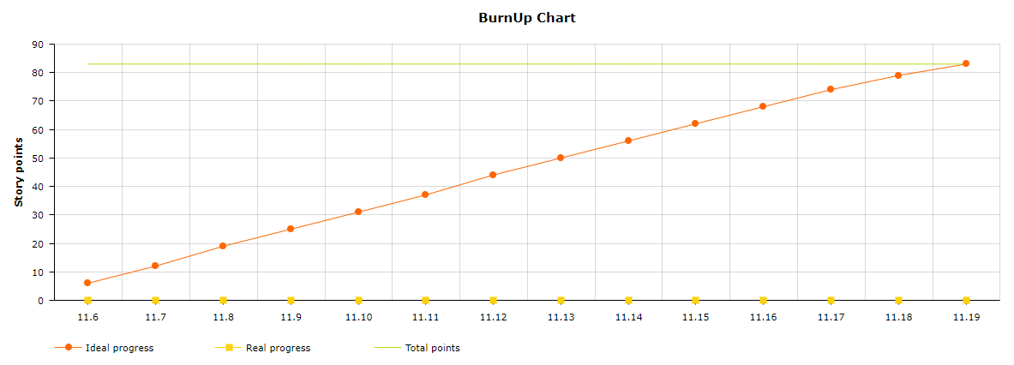

**Initial Scrum Board:**

|  |  |  |  |
| --- | --- | --- | --- |
| **User story** | **To do** | **In progress** | **Done** |
| **User story 1:** As a developer, I want to put the result from search into data structure, because I can easily use these information later on. | **User story 1:** As a developer, I want to put the result from search into data structure, because I can easily use these information later on. |  |  |
| **User story 2:** As a user, I want to be able to have a profile because I want a place to save my information like my preference. | **User story 2:** As a user, I want to be able to have a profile because I want a place to save my information like my preference. |  |  |
| **User story 3:** As a developer, I want to redesign the spider-net web way of showing result, because this feature is way harder than we expected. | **User story 3:** As a developer, I want to redesign the spider-net web way of showing result, because this feature is way harder than we expected. |  |  |
| **User Story 4:** As a user, I want to be able search for movie instead of youtube video because I want to watch movies. | **User Story 4:** As a user, I want to be able search for movie instead of youtube video because I want to watch movies. |  |  |